A rebuttal to Watters et al. ´2020 Long-term observations from Antarctica demonstrate that mismatched scales of fisheries management and predator-prey interaction lead to erroneous conclusions about precaution´

2025-10-13

Abstract

Characterising the impact of human activities on wildlife is a key function of applied science. In the Antarctic Peninsula, the fishery for Antarctic krill has been operating for over half a century, and concerns that fishery-driven localised depletion of krill around pygoscelid penguin colonies could have deleterious effect on their performance and demographic trends have been raised. One study utilises 30 years of penguin foraging and reproductive performance of penguins at two colonies in the South Shetland Islands matched against acoustic measurements of krill biomass and krill catches at the gSSMU scale (Watters, Hinke, and Reiss 2020). Herein we provide an assessment of the efficacy of this approach in drawing conclusions as representing sound scientific advice, given that the study in question is now being used as such. We demonstrate that several underlying assumptions in the Watters et al. 2020 study are contrary to the published scientific literature and not supported by the data provided by the authors themselves. When the modelling appraoch is reformulated to account for these inaccuracies, we demonstrate that the impact on penguin performance of fishing activity is greatly reduced, and that the dominant driver of penguin performance is the Oceanic Niño Index. We conclude that the original study should be treated with caution when used as a basis for fisheries management advice.

# Introduction

Concerns over the potential impact of localised depletion of krill through concentrated fishing effort on krill-dependent predators has been a topic of debate within the Antarctic science community for many years. Recently, one study has been presented that suggest that local harvesting rates can impact predator performance to the same degree as poor environmental conditions (Watters, Hinke, and Reiss 2020) by matching various performance indices of krill-dependent penguins relative to estimates of krill biomass, fishing pressure and broad scale climate variability. The penguin performance indices were collected at two sites (Cape Shireff on Livingstone Island and Copacabana on King George Island, South Shetland Islands; Figure 1) in the period 1982 - 2016 whereas krill abundance data, which cover the at-sea distributions of chinstrap, gentoo and Adélie penguins, were collected during summer (1996 - 2011) and winter (2012, 2014 and 2015). By drawing in monthly krill catches from Catch and Effort data reported to CCAMLR and climate data (ONI), the authors use a hierarchical analysis of variance approach to estimate the variance in these indices as a function of Local Krill Biomass (LKB), Local Harvesting Rates (LHR; the ratio of krill catch to LKB) and the Oceanic Niño Index (ONI). The study drew the conclusion that local harvesting levels of krill adversely impact penguins, and the degree of impact can either be similar to that of poor environmental conditions or have a synergistic impact when high local harvesting coincides with poor conditions.

The conclusions of this paper, which at the time of writing has accumulated 162 citations, have been used by CCAMLR in support of developing Marine Protected Area proposals and fisheries management strategies as well as being used in the review process of the Marine Stewardship Council fisheries certification process for Antarctic krill. In other words, the outcomes of this study have been propagated into geopolitical and socioeconomic environments that are having real-world impacts beyond a scientific debate. However, there are several areas of concern regarding the structuring of this study that deserve attention. Firstly, we review Watters, Hinke, and Reiss (2020) through the lens of the ecological assumptions underpinning the study conclusions, versus the available evidence supporting them. Secondly, we quantitatively assess how rationalising these assumptions to the evidence available changes the model outputs and on the conclusions drawn. We then highlight some overarching concerns applicable to the paper.

## Testing of the ecological assumptions underpinning the modelling approach

1. The biomass of krill available at spatial scales relevant to penguins varies depending on the phase of the Southern Annular Mode (SAM).

## Mismatched scales of predator monitoring and fisheries management

A key goal for the paper is to highlight the consequences of mismatching scales at which the Antarctic krill fishery is managed with the scales at which ecological interactions between fishing extractions and dependent predators occur. To do this, they create two strata aligned with groups of SSMU (gSSMU); gSSMU #1 including those SSMU inside the Bransfield Strait (APBSE and APBSW) and gSSMU #2 incorporating SSMU north of the South Shetlands, including Elephant Island (APDPE, APDPW and APEI) represented in Figure 1. These gSSMU cover $15,500nm^{2}$ and $20,600nm^{2}$, respectively, and are used to characterise both krill biomass and harvesting rates that are “local” to the penguin colonies for which performance data are used. The reasoning behind scaling to gSSMU are linked to the foraging behaviour of the penguins for which performance data area available i.e. breeding, adult pygoscelids. The authors cite Hinke et al. (2017) as the evidence supporting usage of the two gSSMU as appropriate strata.

Pygoscelid penguins exhibit staggered breeding, with Adélies commencing first, followed by chinstraps then gentoos (Black 2016). Adélie penguins are the first to fledge their chicks and thus cease to be centrally foraging, typically departing mid-February for their moulting grounds on the sea ice. chinstrap penguins depart for a pre-moult foraging trip towards the end of February and return to land in order to moult, before departing again for their overwinter trip Hinke et al. (2015); Hinke et al. (2019). Conversely, gentoo penguins appear to remain near their breeding colonies overwinter (Korczak-Abshire et al. 2021).

We use the Argos-CLS PTT telemetry data provided by the supporting studies to characterise the actual at-sea habitat used, in the context of the relative stage of breeding for each species (though we also recommend Warwick-Evans et al. (2018) and Lowther et al. (this meeting) amongst other work, for further quantification of foraging behaviour of breeding penguins in this area). For each species, we refrain from undertaking extensive state-space modelling of location errors and merely exclude locations with a “Z” error class, accepting the remaining locations had varying degrees of uncertainty around them, then calculated the 99% Minimum Convex Polygon (home range) using the R package adehabitatHR and calculate their associated areas in $nm^{2}$. For chinstrap penguins at Cape Shireff, this equated to a home range area of ~ $4,782nm^{2}$, or only 23% of the gSSMU to which their performance metrics are indexed against (Watters, Hinke, and Reiss 2020). For the same species at Copacabana the 99% MCP home range is 2,905 $nm^{2}$, or ~19% of gSSMU 1 in the Bransfield Strait. Similarly for Adélie penguins, the breeding foraging range occupied 1,139 $nm^{2}$ or only ~7% of the area of gSSMU #1. After breeding, available overwinter PTT telemetry and light geolocating data on chinstrap and Adélie penguins suggests a wide dispersal westwards into the Pacific sector of the Southern Ocean, and eastwards into the Weddell Sea and Atlantic sectors, with a relatively small proportion of chinstraps from the study sites remaining within 500km of their breeding colonies (Hinke et al. 2019). Yet despite the evidence supporting widescale post-breeding migration of both Adélie and chinstrap penguins, the model used by Watters, Hinke, and Reiss (2020) constrains both species from Copacabana to gSSMU #1 and chinstraps from Cape Shireff to gSSMU #2 over winter (Supplementary Material 1 & 2, code lines 258 to 279). This has the effect of constraining the variability in performance indices from these species to LHR, LKB and ONI over winter in areas where the species has a demonstrated tendency to migrate away from (Figure 2). This is particularly important given that the fishery can now be characterised with a late autumn/early winter start which places a seasonal element on LHR towards increased values in the winter (Figure 5).

Our preliminary review thus far raises two areas of concern. Firstly, that the scales at which “local” predictors are summarised are in some cases almost 15 times larger than the habitat exploited by the penguins monitored. Local Harvest Rate is a function of the catch and its distribution; we demonstrate catch distribution varies across breeding seasons within the original gSSMU, using available C1 Catch and Effort data during the austral summer period, relevant to the breeding season and thus centrally foraging Adélie and chinstrap penguins between 2009 and 2018 for Subarea 48.1 (Figure S1).

Secondly, that the known overwinter migratory behaviour of Adélie and chinstrap penguins are poorly reflected in the model formulation. To demonstrate the impact that these ecological assumptions have on the model output, we rerun the model of Watters, Hinke, and Reiss (2020) with modified code. To avoid an overly burdensome paper, we shortly summarise those code changes here, and if requested during the meeting we are happy to include the rmarkdown version of this paper with the modified code in place, or submit the modifications to the meeting in some other format.

We also note an additional coding error that may influence how the original, unmodified results are interpreted. In summarising the model outputs into boxplots, the text in the paper seemingly classifies the “Worst Case” with “neutral” ONI ( $−0.5$ $​^{∘}$ C < ONI < 0.5 $​^{∘}$ C; LKB > 1 Mt; and LHR $≥$ 0.1) and the code relating to developing the original manuscript Figure 2 (Supplementary Material 1, lines 661-663) uses Parameter set 36 from the output dataframe, which actually reflects a “warm” ONI component (> 0.5 $​^{∘}$ C; LKB > 1 Mt; and LHR $≥$ 0.1). Yet the discussion in Watters, Hinke, and Reiss (2020) also suggests that the likelihood of their “Worst Case” includes future warming (see Figure 3 below)

We agree that any “Worst Case” should reflect ENSO conditions into the future under a warming climate. However, climate change is likely to increase ENSO in amplitude - both El Niño (ONI “warm”) and La Niña (ONI “cold”) (Capotondi et al. 2015). How this increasing amplitude can be integrated appropriately into the presented modelling framework to match with long-term predicted mean performance of predators has not been explored yet. As such, and for the sake of comparison with the original study, we maintain the authors designation of ONI “neutral” when rendering the “Worst Case” boxplots, though caution that this is unlikely to be a realistic assumption

## Modifications to model parameters

We scale the gSSMU LKB to the SSMU that the summer tracking data indicate penguins occupied. To do this, we calculate the area ($nm^{2}$) of the SSMU for which the predator occupies and the gSSMU to which it is assigned, then create a scaling ratio. For example, we scale LKB for Cape Shireff chinstrap penguins solely to ADPDW (Figure 1) by multiplying the gSSMU LKB by the areal ratio of ADPDW/gSSMU #2. We then select the corresponding SSMU catch values provided in Watters, Hinke, and Reiss (2020) (Supplementary Info) to estimate SSMU-scale LHR. We also caution that while considering the gSSMU scale of harvesting as inappropriate for “local” effects, even the SSMU-scale catch levels likely do not reflect pressures at scales relevant to breeding penguins (Supplementary Figure 1).

We remove Adélie and chinstrap penguins from the model formulation over winter; that is, we attribute each species as “NA” during winter (to account for dispersal after breeding), thus removing them from association with any gSSMU.

The authors place LKB/LHR values in March into the “summer” period. However fishing effort over the period that performance indices are available is not uniform over the thirty year period, with catch over the preceding decade tending towards a nonlinear increase from the middle of March and three years where catch rates increased rapidly from the beginning of the month (Figure 4). Given the highly variable rates of catch throughout the study period, we run scenarios that classify March as either summer or winter to reflect the linkage between March and the breeding state of penguins i.e. Adélie and chinstrap penguins have either migrated out of the area or have ceased to be centrally foraging species by March.

Thus we reformulate the underlying assumptions above into a new model construct, in which performance indices from gentoo, chinstrap and Adélie penguins during the summer are included, but Adélie and chinstrap penguins cease to be centrally foraging species after breeding and migrate out of the area. The performance indices are matched in space and time but using SSMU level estimates of LKB and LHR. We re-run the model that includes imputed values for LKB in years where survey data are missing. We further consider two alternatives for considering March, either in a) summer or b) winter.

We present the outputs both in the same boxplot format as Figure 2 in the original manuscript, and as individual cases grouped and colour-coded as ONI “warm” ( $≥$ 0.5; red), ONI “neutral” (-0.5 < ONI > +0.5; white) and ONI “cold” (< -0.5; blue). We also recreate the original marginal probabilities in Table 1 of Watters, Hinke, and Reiss (2020), and two additional tables in the same format with the probabilities extracted from our reformulated model, the difference between the latter two tables reflecting whether March is in summer or winter.

### Results

From the original Watters, Hinke, and Reiss (2020) model, the probability that the Worst Case would cause penguin performance indices to drop below their long-term mean was 77%, while relative to the Best Case there was a 93% probability that penguin performance would decline as a response to high LHR. Similarly, there was a 99% probability that high LHR and LKB under neutral ONI (“Worst Case”, though see above for comments on this) would drive penguin peformance to fall below its long term mean (Table 1).

Our reformulation displays a rather different picture, and while we refrain from providing an exhaustive in-text comparison, we highlight a few examples here. Comparing the original model outputs with ours, relative to the “Best Case”, the probability of negative impacts to penguins due to high LHR dropped precipitously from $≥$ 93% to 37% (Table 3). In other words, when considering the migration of penguins in accordance with their known ecology (Figure 2), the relative probability of negative impact of LHR drops from a near-certainty to 1-in-3 (Table 2 and 3). Given the temporal separation between fishing and penguin breeding over the preceding decade, our results are unsurprising.

The probability that the effects of warm or neutral ONI would be more detrimental to penguin performance were greater than for the Worst Case (Table 2 and 3). When we consider the marginal effects of neutral ONI and high LHR, the probabilities that the former would negatively impact penguin performance below the long-term mean was 4 times greater than the impact of high LHR (Table 2 and 3). Looking at the case-by-case and selected plots in Figure 4 the overwhelming dominace of the ONI state can clearly be seen. La Niña (“cold” ONI) conditions resulted in predictive probabilities of performance that were equal to, or surpassing, those of the Best Case irrespective of increased LKB or LHR. Even more counterintuitively, an increase in LHR to even high levels has a lower probability of decreasing penguin performance than that of the Best Case (Table 2 and 3). However, it is important to note that overall our intention is not to suggest that increased fishing is beneficial; merely that when the model is reconditioned on ecological knowledge, the outputs in its current formulation should be treated with caution.

In summary, Watters et al. (2020) believe that penguins are responding to both the environment and fishing. We agree that penguins are responding to the environmental changes, however we believe that the fishery effect is flawed because the scales at which their model incorporates fishing bear no relevance to the scales at which penguins exploit (Figure S1). The penguin performance in the orginal model was also insensitive to marginal changes in LKB which corroborate previous failed attempts to parameterise functional responses of penguins. This insensitivity is in line with our results, but we propose that even the SSMU scale is inappropriate for matching food availability and harvesting pressure to predator performance (Figure S1).

In light of these findings, and the scales of management originally proposed by us in WG-EMM 2019/18, we support the direction of discussions during WG-ASAM this year to consider spatial scales of management to areas in which the fishery operates, rather than at the Subarea level.

# Discussion

Our preliminary review of Watters, Hinke, and Reiss (2020) demonstrates that the conclusions drawn by the authors are based on assumptions that are not supported by the data used to derive them.

Of greatest concern, however, is that the interpretation of model outputs from both approaches (either from both the original study or our parameter modifications to account for current knowledge of penguin movement) are under boundary conditions that we feel are not appropriate. The study only considers the fishery and broad-scale climate phenomena as the only two causes of krill abundance variability at geographic scales relevant to penguins. The authors do not, for example, the impact of rebounding baleen whale populations ((Johannessen et al. 2022)) or migratory male Antarctic fur seals ((A. D. Lowther et al. 2020)) beyond a cursory acknowledgement that their impact on penguin performanc is unknown. Humpback whales have increased in abundance throughout the life of the krill fishery and consume orders of magnitude more krill yet the modelling approach used effectively ignores this much more efficient fisher of krill. There are sufficient telemetry and distance sampling studies in the scientific literature to demonstrate the degree and significance of spatiotemporal overlap with breeding penguin populations (see Santora and Veit (2013), A. D. Lowther et al. (2020) and Figure S2 as examples) and the distribution of these competitors are not uniform in either space or time making the inclusion of their impact on local availability of krill extremely challenging.

Similarly, the utilisation of broad-scale climatological phenomena to characterise impacts at scales that predators are dependent upon is problematic. The Amundsen Sea Low (ASL) is the dominant climate feature for the western Antarctic Peninsula. The El Niño-Southern Oscillation modulates the ASL, with El Niño (La Niña) shallowing (deepening) its pressure, causing more northwesterly (southeasterly) winds and upwelling (restricted influx) of Circumpolar Deep Water onto the shelf. The Southern Annular Mode also influences the pressure of the ASL, with the current trend of negative SAM constructively (destructively) interfering with ASL when in phase with El Niño (La Niña) events (e.g. Clem et al. (2016)). The result is a set of above-surface climate conditions that drive changes in water mass intrusion that is in turn dependent on *interactions* between two climate processes as well as the geographical orientation of the coastline involved, all of which have been shown to impact the foraging trajectories and trip durations of Chinstrap penguins (Andrew D. Lowther et al. 2018). The bathymetry of the Antarctic Peninsula which also influences the hydrographic conditions is complex (particularly at scales that are important to centrally-foraging predators such as penguins) and the structuring of krill aggregations in time and space in the WAP have been linked to mesoscale circulation processes (Santora et al. 2012), which are unlikely to be uniformly affected by macroscale processes. It is also worth noting that the study considers neither the impact of climate on the terrestrial breeding grounds, such as chick mortality through “wetting down” by increased rainfall (Chapman et al. 2011) nor the unaccounted-for measurement inaccuracies in the foraging trip durations used by Watters, Hinke, and Reiss (2020; Andrew D. Lowther et al. 2015), the general structure of the study does not appear to be appropriate for answering the research questions raised.

Our goal is to ensure that the best available objective scientific evidence is presented to the environmental managers tasked with conserving and sustainably exploiting the Antarctic marine ecosystem. Over twenty years ago, CCAMLR acknowledged that its monitoring program (CEMP) was not capable of disentangling the relative impacts of fishing and climate change on krill-dependent predators (REF). The CEMP program has not been modified in the intervening two decades,

Summary Table showing what was bullshit, and where to find the analysis and data in our paper.

Statement/Question

Data Source

Support & Significance

Appendix Reference

Does LKB vary with SAM sign and strata ?

Appendix I

No; F < 0.975, p >0.33 all cases

LKB does not vary predictably with SAM

Is low LKB (<1Mt) correlated with small krill ?

Appendix II

No; F < 2.175, p >0.154 all cases

Low LKB in Best Case scenario is inappropriate

Are penguin indices related to ONI/SAM ?

Appendix III

No; see Appendix III Table 1

Penguin indices are not correlated to climate variability indices

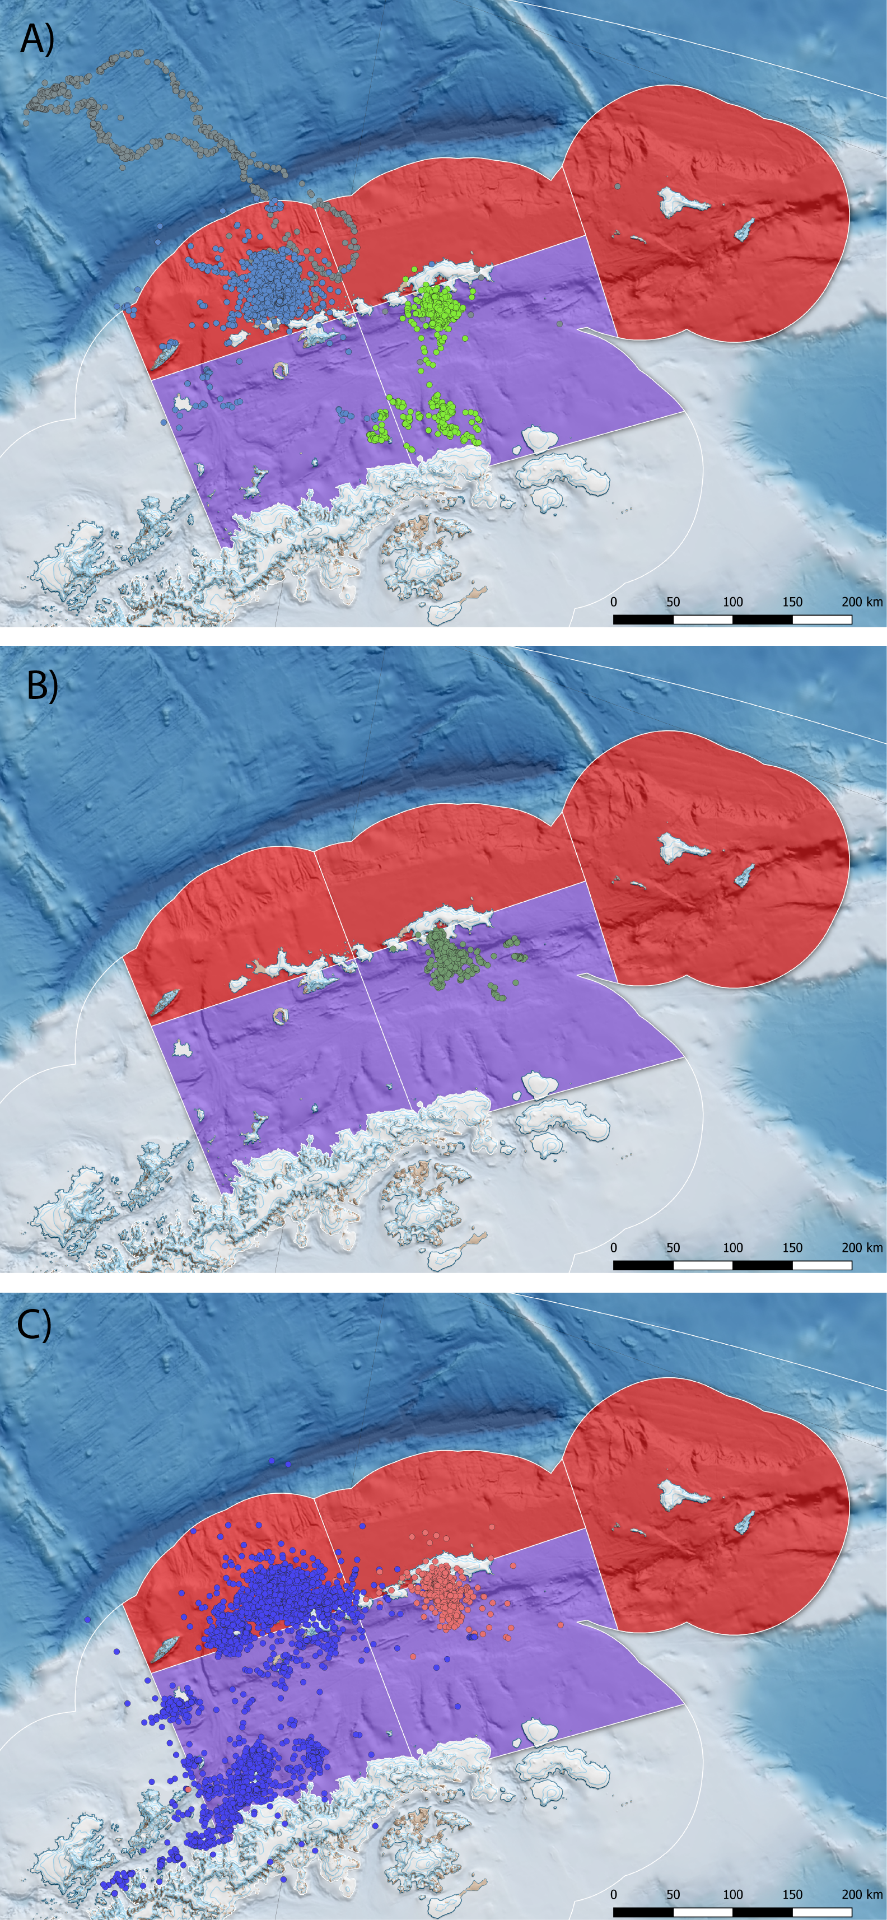

Penguin foraging behaviour during summer breeding, derived from available ARGOS-CLS PTT data presented in Hinke et al. 2017. A) Chinstrap penguins from Cape Shireff (blue) and Copacabana (green) truncated at ${10}^{th}$ March in line with known phenology (Black 2016; Lowther et al.(this meeting). Elongated grey track represents a single animal) B) Adélie penguins truncated to the end of January and C) gentoo penguins until August, representing all available PTT data provided. The SSMU are combined and coloured according to gSSMU (red; gSSMU 2, purple; gSSMU 1) with chinstrap and Adélie penguin 99% MCP home ranges occupying between 7-19% of the gSSMU to which they were assigned.

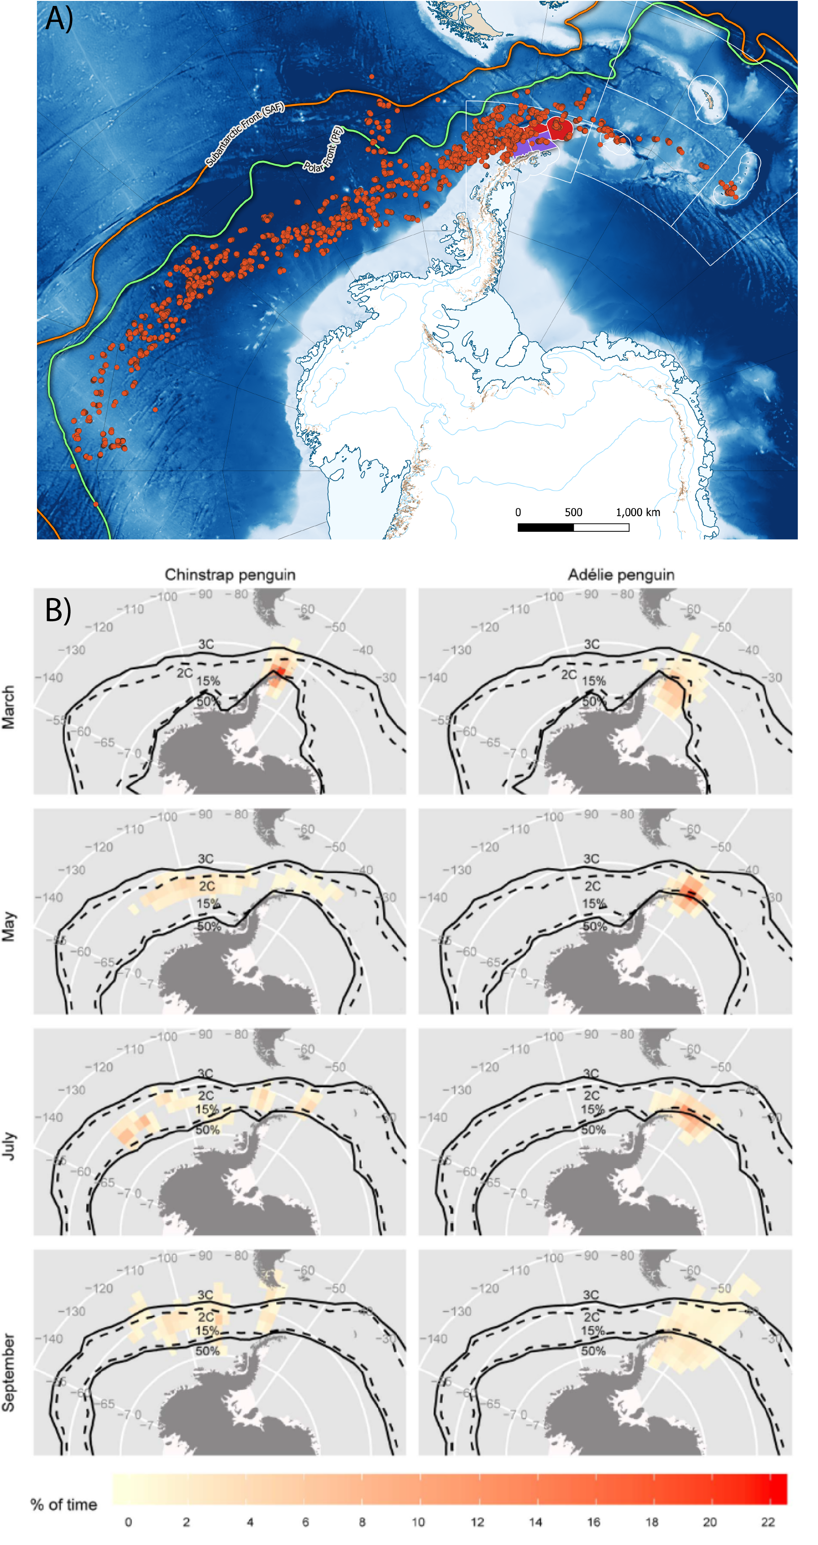

A) Distribution of overwinter movement for chinstrap penguins, relative to the gSSMU’s to which they were attributed, created from telemetry data available in Hinke et al. 2019. B) Adélie and chinstrap penguin movement recorded by light geolocators, highlighting the large longitudinal range both species disperse through at the end of breeding (taken from Hinke et al. 2015). In the original model formulation by Watters et al. 2020, the winter performance indices for both species are matched to macroscale levels of ONI variability but gSSMU-scale estimates of LKB and LHR.

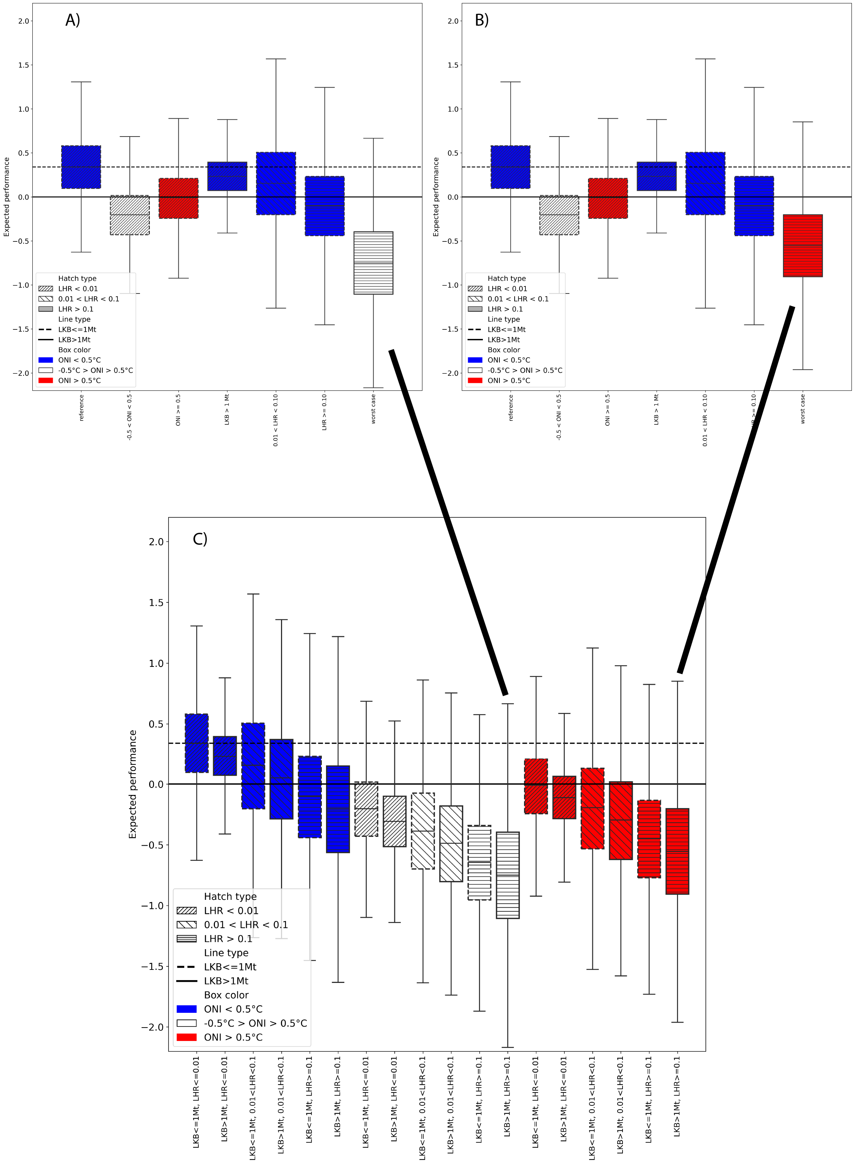

Original Figure 1 plot from Watters et al. 2020 with A) Neutral ONI and B) B) Warm ONI constituting the Worst Case selected. C) Displays the original case-by-case plots recreated from the paper, with Case 12 representing the intention while data from Case 18 was selected for rendering the boxplot. Note that the expected performance under neutral ONI Worst Case is poorer than under the warm ONI that was presented in the original paper. Henceforth, to facilitate comparison, we refer to the ONI Neutral plot however we consider this unrealistic if the intention is to portray a Worst Case of a continuing warming climate.

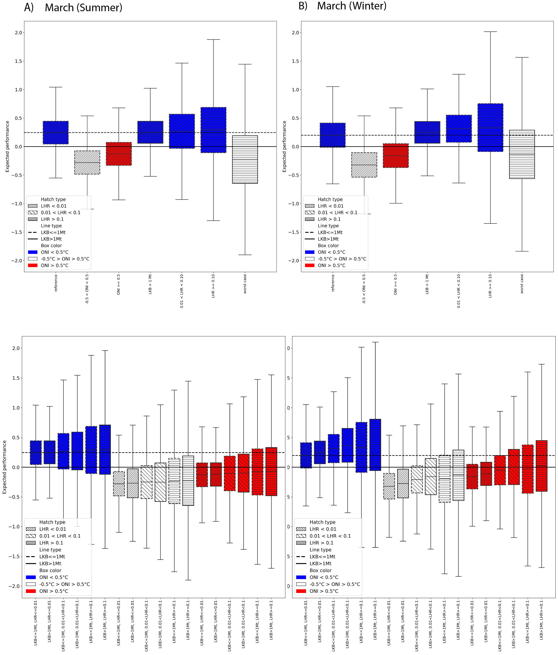

Model output for the alternatve Watters et al. 2020 scenario outlined above (all species initially present, Adélie and chinstrap penguins migrate out of the area after breeding, LKB and LHR rescaled to SSMU and March included in summer or winter). Selected cases as per Watters et al. 2020 for March in A) Summer and B) Winter are provided, with the corresponding case-by-case boxplots presented beneath. Boxplots are colour-coded by ONI state (red=warm, white=neutral, blue=cold). In all cases, the marginal effect of ONI dominated the expected performance of penguins against their long-term mean, irrespective of LKB or LHR.

Original table in Watters et al. 2020. In this and all subsequent tables below, the posterior and posterior predictive probabilities that the expected performance of penguins given the effects in the left hand column are less than the expected performance given the drivers in the column headings are provided. Worst Case is represented by neutral ONI; LHR $≥$ 0.1; and LKB $≥$ 1Mt. The Best Case is represented by La Niña conditions, low LKB and low LHR.

Effects

Best Case

-0.5 $​^{∘}$ C < ONI < +0.5 $​^{∘}$ C

ONI $≥+0.5$

Long-term $μ$

Long-term predicted $μ$

Best case

NA

NA

NA

0.04

0.36

ONI Neutral

1.00

NA

NA

0.89

0.59

ONI warm

0.99

NA

NA

0.52

0.51

LKB High

0.71

0.02

0.12

0.01

0.41

LHR medium

0.75

0.16

0.31

0.32

0.44

LHR high

0.93

0.39

0.61

0.64

0.54

Worst case

0.99

NA

NA

0.99

0.78

Posterior and posterior predictive probabilities extracted from the model output for alternatve Watters et al. 2020 scenario outlined above with March attributed to winter (Adélie and chinstrap penguins migrate out of the area after breeding, LKB and LHR rescaled to SSMU). Under this scenario, performance against the long term mean is worst for neutral and warm ONI conditions.

Effects

Best Case

-0.5 $​^{∘}$ C < ONI < +0.5 $​^{∘}$ C

ONI $≥+0.5$

Long-term $μ$

Long-term predicted $μ$

Best case

NA

NA

NA

0.04

0.40

ONI Neutral

1.00

NA

NA

0.97

0.62

ONI warm

0.99

NA

NA

0.81

0.56

LKB High

0.49

0.01

0.05

0.03

0.40

LHR medium

0.46

0.04

0.09

0.14

0.39

LHR high

0.45

0.10

0.16

0.23

0.39

Worst case

0.84

NA

NA

0.71

0.59

Posterior and posterior predictive probabilities extracted from the model output for alternatve Watters et al. 2020 scenario outlined above with March attributed to summer (Adélie and chinstrap penguins migrate out of the area after breeding, LKB and LHR rescaled to SSMU). Under this scenario performance against the long term mean is also worst for neutral and warm ONI conditions.

Effects

Best Case

-0.5 $​^{∘}$ C < ONI < +0.5 $​^{∘}$ C

ONI $≥+0.5$

Long-term $μ$

Long-term predicted $μ$

Best case

NA

NA

NA

0.10

0.42

ONI Neutral

1.00

NA

NA

0.98

0.63

ONI warm

0.99

NA

NA

0.86

0.56

LKB High

0.40

0.00

0.04

0.03

0.40

LHR medium

0.27

0.01

0.02

0.04

0.37

LHR high

0.37

0.08

0.13

0.21

0.38

Worst case

0.76

NA

NA

0.63

0.55

# Supplementary material

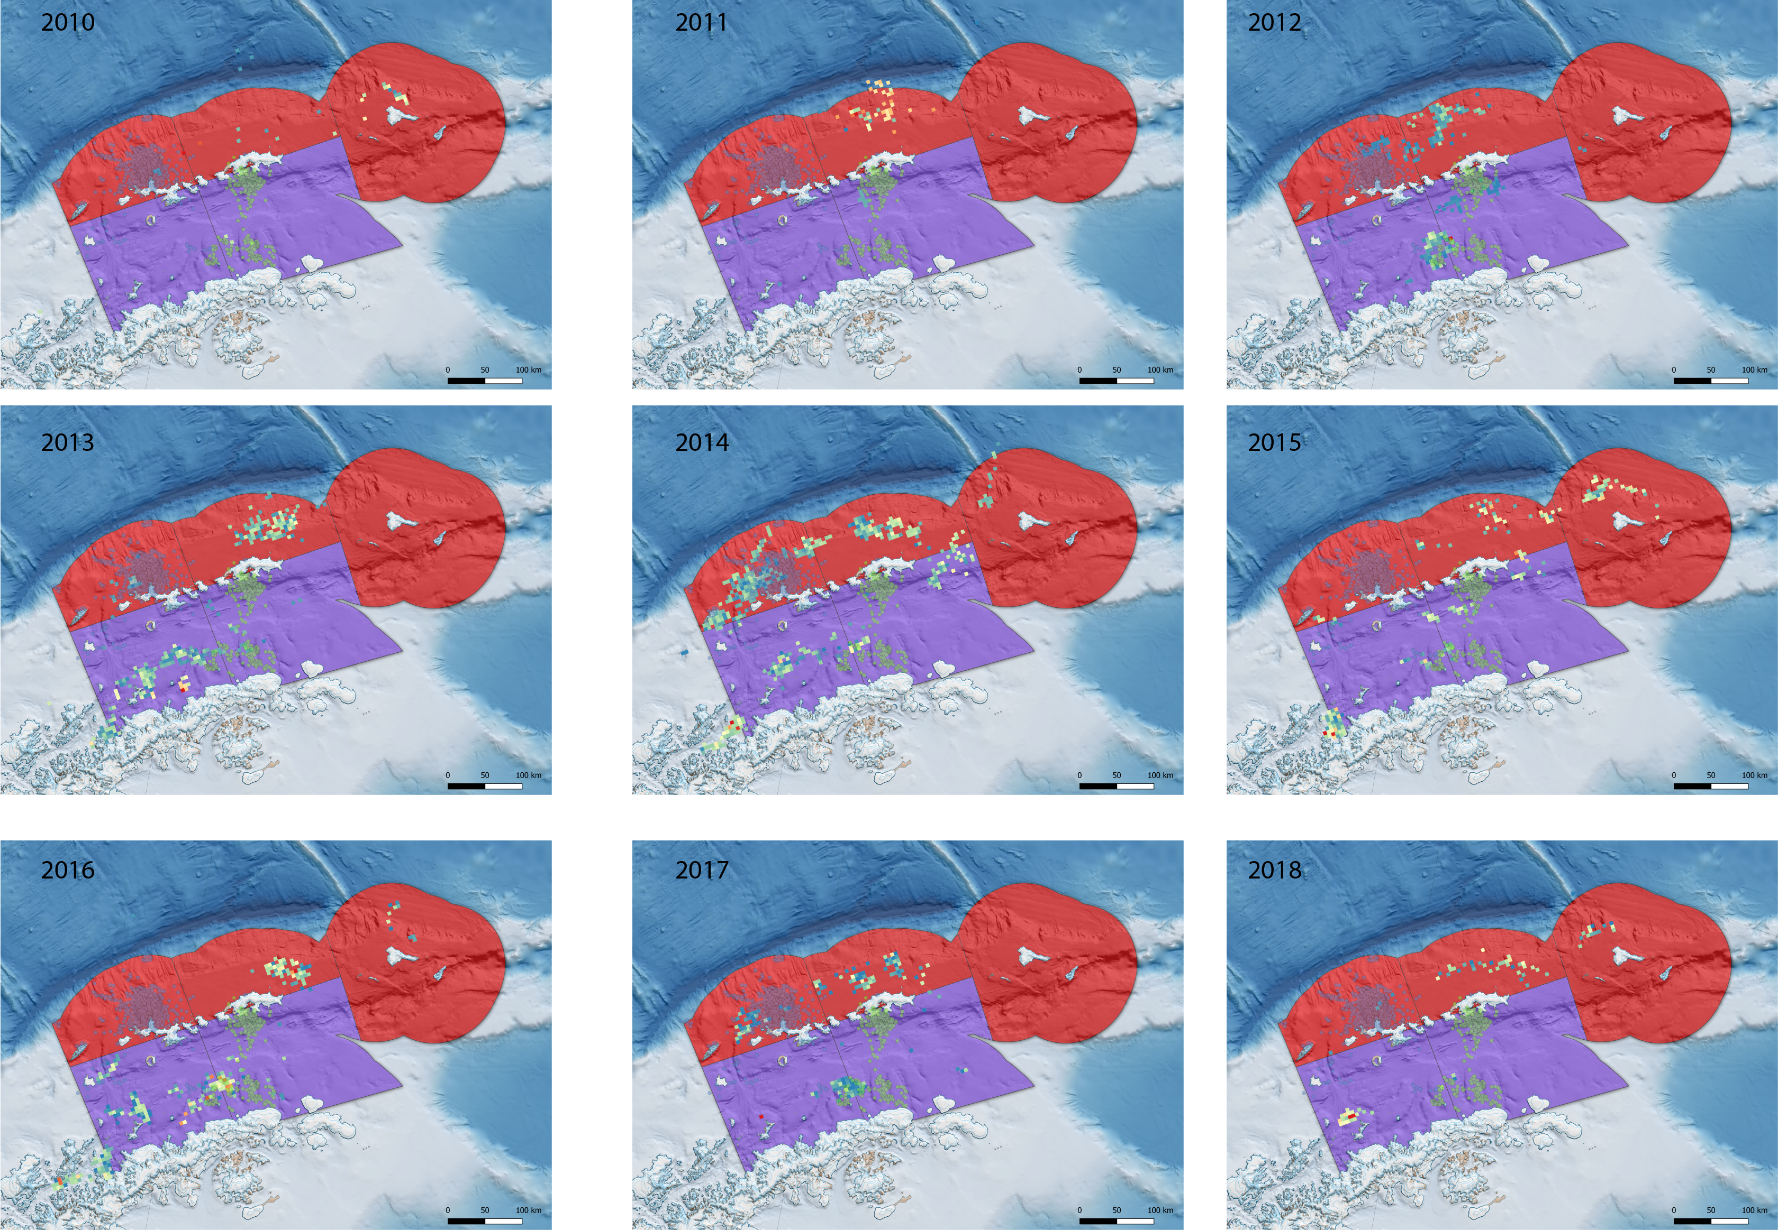

C1 Catch and Effort data for 2010 - 2018, for all catches during the period of the austral summer relating to Adélie and chinstrap penguins in Subarea 48.1 (i.e. up to ${10}^{th}$ March). The telemetry data presented in Hinke et al. 2017 for chinstrap penguins at both Cape Shireff and Copacabana and the gSSMU used in the Watters et al. 2020 paper are superimposed to highlight the extreme variability in actual catch, relative to the scale of LHR used to reflect interactions with penguins. Our reanalysis re-scaled LHR to the SSMU level, though we contend that for the purposes of matching predator data at appropriate spatial scales even this is too coarse a resolution.

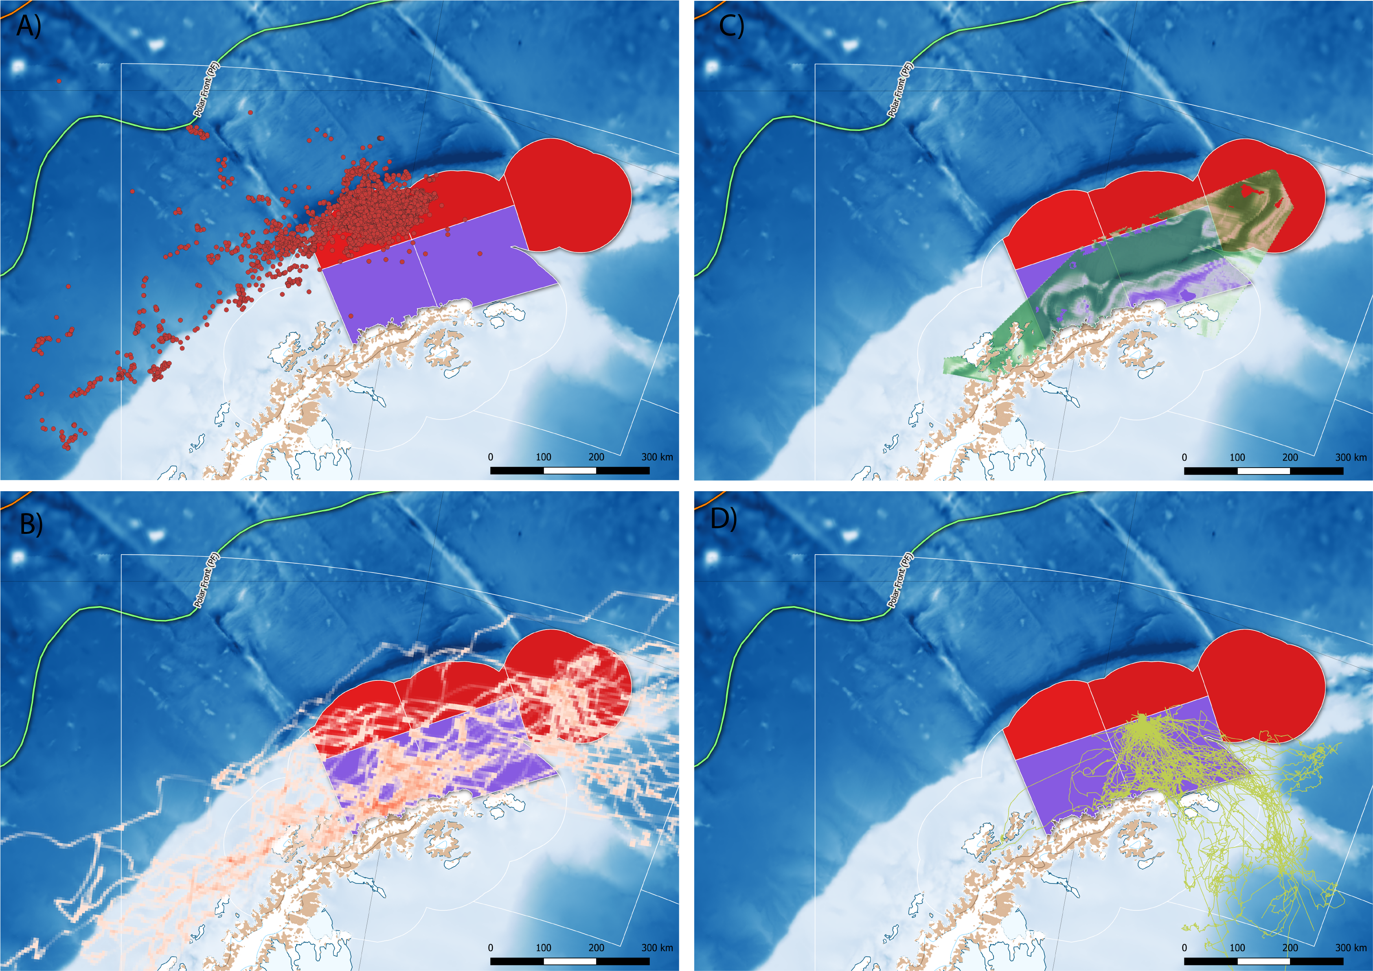

The summer distribution of foraging effort by A) adult female Antarctic fur seals (adapted from telemetry data available in Hinke et al. 2017), B) migratory adult male Antarctic fur seals (adapted from Lowther et al. 2020) C) humpback whales throughout December (adapted from Johannessen et al., this meeting) and D) nonbreeding adult Adélie penguins during the breeding season (adapted from data in Oosthuizen et al., this meeting). Potential effects of competitive overlap between pygoscelid penguins and other krill dependent predators, particularly those who have increased their abundance dramatically over the preceding 40 years, are excluded from both approaches, creating an unrealistic set of boundary conditions for interpreting the variance in penguin vital rates.

# Citations

Black, Caitlin E. 2016. “A Comprehensive Review of the Phenology of Pygoscelis Penguins.” *Polar Biology* 39 (3): 405–32. <https://doi.org/10.1007/s00300-015-1807-8>.

Capotondi, Antonietta, Andrew T. Wittenberg, Matthew Newman, Emanuele Di Lorenzo, Jin-Yi Yu, Pascale Braconnot, Julia Cole, Boris Dewitte, Benjamin Giese, and Eric Guilyardi. 2015. “Understanding ENSO Diversity.” *Bulletin of the American Meteorological Society* 96 (6): 921–38.

Chapman, Erik W., Eileen E. Hofmann, Donna L. Patterson, Christine A. Ribic, and William R. Fraser. 2011. “Marine and Terrestrial Factors Affecting Adélie Penguin Pygoscelis Adeliae Chick Growth and Recruitment Off the Western Antarctic Peninsula.” *Marine Ecology Progress Series* 436: 273–89.

Clem, Kyle R., James A. Renwick, James McGregor, and Ryan L. Fogt. 2016. “The Relative Influence of ENSO and SAM on Antarctic Peninsula Climate.” *Journal of Geophysical Research* 121 (16): 9324–41. <https://doi.org/10.1002/2016JD025305>.

Hinke, Jefferson T., Anthony M. Cossio, Michael E. Goebel, Christian S. Reiss, Wayne Z. Trivelpiece, and George M. Watters. 2017. “Identifying Risk: Concurrent Overlap of the Antarctic Krill Fishery with Krill-Dependent Predators in the Scotia Sea.” *PLoS ONE* 12 (1): e0170132. <https://doi.org/10.1371/journal.pone.0170132>.

Hinke, Jefferson T., Michael J. Polito, Michael E. Goebel, Sharon Jarvis, Christian S. Reiss, Simon R. Thorrold, Wayne Z. Trivelpiece, and George M. Watters. 2015. “Spatial and Isotopic Niche Partitioning During Winter in Chinstrap and Adélie Penguins from the South Shetland Islands.” *Ecosphere* 6 (7): 125. <https://doi.org/10.1890/ES14-00287.1>.

Hinke, Jefferson T., Maria M Santos, Malgorzata Korczak-Abshire, Gennadi Milinevsky, and George M Watters. 2019. “Individual Variation in Migratory Movements of Chinstrap Penguins Leads to Widespread Occupancy of Ice-Free Winter Habitats over the Continental Shelf and Deep Ocean Basins of the Southern Ocean.” *PLoS ONE* 14 (12). <https://doi.org/10.1371/journal.pone.0226207>.

Johannessen, John Elling Deehr, Martin Biuw, Ulf Lindstrøm, Victoria Marja Sofia Ollus, Lucía Martina Martín López, Kalliopi C. Gkikopoulou, Wessel Chris Oosthuizen, and Andrew Lowther. 2022. “Intra-Season Variations in Distribution and Abundance of Humpback Whales in the West Antarctic Peninsula Using Cruise Vessels as Opportunistic Platforms.” *Ecology and Evolution* 12 (2): e8571. <https://onlinelibrary.wiley.com/doi/abs/10.1002/ece3.8571>.

Korczak-Abshire, Malgorzata, Jefferson T. Hinke, Gennadi Milinevsky, Mariana A. Juáres, and George M. Watters. 2021. “Coastal Regions of the Northern Antarctic Peninsula Are Key for Gentoo Populations.” *Biology Letters* 17 (1): 20200708.

Lowther, A. D., I. Staniland, C. Lydersen, and K. M. Kovacs. 2020. “Male Antarctic Fur Seals: Neglected Food Competitors of Bioindicator Species in the Context of an Increasing Antarctic Krill Fishery.” *Scientific Reports* 10 (1). <https://doi.org/10.1038/s41598-020-75148-9>.

Lowther, Andrew D., Heidi Ahonen, Greg Hofmeyr, W. Chris Oosthuizen, P. J. Nico De Bruyn, Christian Lydersen, and Kit M. Kovacs. 2015. “Reliability of VHF Telemetry Data for Measuring Attendance Patterns of Marine Predators: A Comparison with Time Depth Recorder Data.” *Marine Ecology Progress Series* 538: 249–56. <https://doi.org/10.3354/meps11504>.

Lowther, Andrew D., Phil Trathan, Arnaud Tarroux, Christian Lydersen, and Kit M. Kovacs. 2018. “The Relationship Between Coastal Weather and Foraging Behaviour of Chinstrap Penguins, Pygoscelis Antarctica.” *ICES Journal of Marine Science* 75 (6): 1940–48. <https://doi.org/10.1093/icesjms/fsy061>.

Santora, Jarrod A., William J. Sydeman, Isaac D. Schroeder, Christian S. Reiss, Brian K. Wells, John C. Field, Anthony M. Cossio, and Valerie J. Loeb. 2012. “Krill Space: A Comparative Assessment of Mesoscale Structuring in Polar and Temperate Marine Ecosystems.” *ICES Journal of Marine Science* 69 (7): 1317–27.

Santora, Jarrod A., and Richard R. Veit. 2013. “Spatio-Temporal Persistence of Top Predator Hotspots Near the Antarctic Peninsula.” *Marine Ecology Progress Series* 487: 287–304. <https://doi.org/10.3354/meps10350>.

Warwick-Evans, Victoria, Norman Ratcliffe, Andrew D. Lowther, Fabrizio Manco, Louise Ireland, Harriet L. Clewlow, and Philip N. Trathan. 2018. “Using Habitat Models for Chinstrap Penguins Pygoscelis Antarctica to Advise Krill Fisheries Management During the Penguin Breeding Season.” Edited by Lucy Hawkes. *Diversity and Distributions* 24 (12): 1756–71. <https://doi.org/10.1111/ddi.12817>.

Watters, George M., Jefferson T. Hinke, and Christian S. Reiss. 2020. “Long-Term Observations from Antarctica Demonstrate That Mismatched Scales of Fisheries Management and Predator-Prey Interaction Lead to Erroneous Conclusions about Precaution.” *Scientific Reports* 10 (1). <https://doi.org/10.1038/s41598-020-59223-9>.